**Recent Advances of a Wearable Sensing Glove and Sensory Feedback Device for Rehabilitation and Improved Control of Impaired Upper Limbs and Prostheses**

Carl Demoldera, Alicia Molinaa, Frank Hammondd,e, and Woon-Hong Yeoa,b,c,*

a George W. Woodruff School of Mechanical Engineering, Institute for Electronics and Nanotechnology, Georgia Institute of Technology, Atlanta, GA 30332, USA.

b Wallace H. Coulter Department of Biomedical Engineering, Parker H. Petit Institute for Bioengineering and Biosciences, Georgia Institute of Technology, Atlanta, GA 30332, USA.

c Center for Human-Centric Interfaces and Engineering, Neural Engineering Center, Institute for Materials, Institute for Robotics and Intelligent Machines, Georgia Institute of Technology, Atlanta, GA 30332, USA.

d Institute for Robotics and Intelligent Machines, Georgia Institute of Technology, Atlanta, GA 30332, USA.

e Adaptive Robotic Manipulation Lab, Georgia Institute of Technology, Atlanta, GA 30332, USA.

* Corresponding author: whyeo@gatech.edu (W.-H.Y.)

**Abstract**

Recent technological advancements in soft actuators, flexible electronics, and data acquisition systems have enabled the creation of a portable, low cost, and unobtrusive wearable sensing glove that is can be used in conjunction with a sensory feedback device. The combination of a wearable sensing glove and a sensory feedback device advances the status quo in healthcare, prosthetics, robotics, and virtual reality applications. This combination has emerged as a promising paradigm to enhance the care provided to patients with neurological and musculoskeletal conditions. This paper includes the most up-to-date materials, sensors, actuators, and system-packaging technologies used to develop a wearable sensing glove and sensory feedback device. This paper will focus on technologies used to develop pressure, strain, and temperature sensors that have been mounted on a wearable sensing glove. Details of the mechanical, electrical, system architecture, and material properties are discussed in detail. The limitations of the current methods and technologies are discussed, as well as the key challenges and the future direction of these technologies. Overall, this paper presents an all-inclusive review of the technologies used to develop a wearable sensing glove and a sensory feedback device.

**Keyboards:** Wearable sensor glove, Sensory transfer device, Sensor glove, Data glove, Feedback device

**1. Introduction**

During the last half century, technology has rapidly advanced allowing us to build wearable devices to measure, enhance, and improve the interactions between our body and the environment. Out of all our body parts, our hands are one of the most important tools we use to interact with and manipulate our environment. For that reason, researchers have developed a wearable sensing glove (WSG), which is a wearable device worn on the hand that includes sensors to measure the interaction between our hands and the surrounding environment. A WSG can utilize a sensor to measure some of the following, but not limited to, parameters: motion, position, temperature, pressure, contact, relative finger location, and various other variables.

Numerous applications have arisen over the past thirty years that require the use of a WSG: virtual reality applications, sign language detection and digitization, and healthcare diagnostics (Dipietro et al. 2008). There are commercial WSGs on the market today that are designed for these applications and this commercial availability demonstrates the maturity of WSGs for certain applications. However, there is a large, growing, and unmet need for a device to transfer the sensory information read from the sensors on the WSG and provide feedback to the user on another part of the body. The need for this device arises from the problems users, who have a form of sensory impairment, face. Sensory impairment is “when one of your senses; sight, hearing, smell, touch, taste, and spatial awareness, is no longer normal (Guide 2021).” Sensory impairment is a symptom of a variety of neurological conditions, such as spinal cord injuries (SCI), cerebral palsy, peripheral neuropathy, sclerosis, and diabetes. Sensory impairment can have drastic consequences for users as it increases the likelihood for injury. “A person feeling pain often reacts automatically by pulling away from the source of injury. For example, someone who puts a hand on a hot stove will pull the hand away immediately when they feel the pain. This reaction helps prevent severe injury. Loss of sensation, however, takes this warning signal away. If you have lost sensation, you may leave your hand on the hot stove. The resulting burn will be very severe (Luke's 2021).” Young children, toddlers, and babies specifically struggle with sensory impairment as it severely stunts their early childhood development. Some infants who suffer from sensory impairment in their fingers, due to damage to the median nerve for example, exhibit “self-mutilation” behavior called dermatophagia. This self-mutilation behavior is defined as “excessive mouthing or biting of any part of the affect limb, and/or loss of any parts of the affected limb secondary to biting and infection (McCann et al.).”

Another user group that would benefit from the use of this device are individuals with a limb prosthetic, as they are currently unable to sense or feel using their prosthetic. The lack of tactile, proprioceptive, and temperature feedback from a limb (whether human or artificial) often leads to a feeling of limb disembodiment. This results in the reduced use of the limb or rejection of the prosthetic altogether [Design and evaluation of a sensory...][7].

Currently, patients with a form of sensory impairment rely on muted sensory information and vision as feedback modes to determine the state of their limbs. The limited feedback can be cumbersome, inaccurate, and dangerous [4]. To combat these problems, researchers have developed a sensory feedback device (SFD) to complement a user’s visual feedback and enhance the user’s experience while they interact with their environment. The need for a device that can communicate the sensory and physical states of a sensory impaired limb is evident.

This literature review provides an extensive survey of the technologies used in WSGs and SFDs. It identifies the advantages and drawbacks of each technology implemented and the potential room for improvements. Additionally, it provides readers with a broad overview on how these technologies can be used in tandem. This literature review is structured in two main sections: WSG and SFD. The WSG portion of the literature review is divided into the following sections: introduction, commercially available products, Do-It-Yourself projects, academic advancements in sensor technology for WSGs, and the limitations and challenges. The academic advancements in sensor technology for WSGs is broken down by sensor node: strain, pressure, and temperature. The SFD portion of the literature review is structured in the following sections: feedback modes, electro cutaneous, vibrotactile, mechanotactile, other novel approaches, and the limitations and challenges. This literature review is concluded by a section commenting on the future direction of this field and the important takeaways for the reader. The motivation for writing this literature review stems from the observation that the important information on WSGs and SFDs are scattered across numerous engineering, commercial, and scientific pieces of literature. Overall, we hope to inform the non-specialist reader who is interested in using a WSG and SFD for their application.

**2. Wearable sensor glove**

WSGs were introduced in the 1980s, with one of the first commercial products being the Nintendo Power Glove that was released in 1989 (Francisco 2020). Researchers started to build WSGs over the next few decades and started to implement rudimentary sensors into them. The first prominent literature survey on WSGs was conducted by Dipietro in 2008 (Dipietro et al. 2008). Since this literature review was conducted, the underlying technology has advanced significantly. Researchers have dedicated resources and time to advance the sensors, materials, and technology used to construct WSGs. Researchers started to place exotic sensors on WSGs enabling them to be used to detect anything from fentanyl (Barfidokht et al. 2019) to diverse biomarkers (Bariya et al. 2020). Additionally, researchers started to apply WSGs to very specific applications: medical applications (Pasquale 2018), hand joint monitoring for rehabilitation (Rashid and Hasan 2019), sign language recognition (Ahmed et al. 2018), hand pose estimation (Chen et al. 2020), and hand gesture recognition (Premaratne 2017).

To provide readers with a more focused literature review, this paper is focused on reviewing WSGs that implement either pressure, temperature, or strain sensors. These sensors were selected for a focused study as they measure the main interaction individuals with sensory impairment disorders need to have transferred to another part of their body. This paper will survey commercial products, Do-It-Yourself (DIY) projects, and academic papers to highlight the manufacturing method, application, and characteristics of the sensors used. The advantages and drawbacks of the technologies used are highlighted to identify potential room for improvements and the future direction of WSGs will be discussed to guide readers in their research development.

**2.1. Wearable sensing gloves applications**

WSGsare used in a multitude of applications, and the number of applications continues to grow as the technology used to make them improves. In 2008, Dipietro created a summary table to detail the applications that WSGs can be used for. This summary table documents possible applications, fields, rationale for their use, the device used instead of a WSG, and their purpose (Dipietro et al. 2008). **Table 1** is an updated version of this prior work and it includes more modern applications that have arisen from technological advances. In the next few sections, the commercially available, DIY, or academic version of the WSGs are described. The commercially available WSGs are listed first to

**2.2. Commercially available wearable sensing gloves**

While numerous WSG designs have been proposed over the past 40 years, only a few products have become commercially viable. The WSGs on the market today integrate a myriad of different sensors. A few notable examples of WSGs that use sensors that are worth mentioning, but are not applicable for this literature review, are the Noitom Hi5 VR Glove (Noitom 2021) that uses an internal measurement unit (IMU) for motion recording, the Workaround ProGlove (Workaround 2021) that uses an industrial bar-code reader for inventory tracking, and the SenseGlove that provides force-feedback for VR training (SenseGlove 2021). Rather this section of the literature review will focus on commercially available products that implement either temperature, pressure, or strain sensors into a WSG.

There are a very limited number of commercially available WSGs that integrate temperature sensors. The SensPro 8108 by Holik International use an infrared thermometer and contact temperature sensors. These sensors are built into a protective glove for firefighters to warn them that the temperature of objects they are touching is too hot (SensPro 2021). The lack of commercially available products that integrate a temperature sensor highlights a potential market opportunity.

Unlike wearable sensing gloves that integrate temperature sensors, there are numerous commercially available WSGs that integrate pressure sensors. **Fig. 3** is provided to help the reader visualize what products are available. Most WSGs that integrate pressure sensors are designed to quantify the ergonomics of a product. The “Pliance Glove” by Novel GmbH, shown in **Fig. 3A,** uses 256 capacitance-based pressure sensors and it records data at a sampling rate of 20,000 samples per second. Tt can additionally be used during physical therapy to assess the severity of a patients injury and aid the patient’s rehabilitation (Novel 2021). The “Finger TPS” by Medical Tactile Inc includes a capacitance pressure sensor on the fingertip of the glove (PPS 2021a). The “TactileGlove,” also by Medical Tactile Inc, includes capacitance pressure sensors throughout the entire glove – fingers to palm, as shown in **Fig. 3G** (PPS 2021b). The “Glove Pressure Mapping System” by Vista Medical, Ltd is has various pressure sensors mounted on the hand at different locations. An image of the glove is shown in **Fig. 3L** (Vista Medical). The “Peregrine Glove ST” by Peregrine has 17 touch point contact sensors (5 touch sensors per long finger and 2 touch sensors on the small finger) as shown in **Fig. 3I**, and it primarily used for computer interaction and VR applications (Peregrine 2021).

The bulk of the commercial WSGs integrate strain sensors for various applications. The largest applications for WSGs that use strain sensors are virtual and augmented reality and computer control, and the following products are designed for these applications. The “VMG 8” by VRealities LLC uses one embedded strain sensor per finger to accurately measure the finger movements as shown in **Fig. 3B** (Virtual Realities 2018). The “MoCap Pro” by StretchSense uses multi-segmented splay sensors to detect the bending of each knuckle as well as the lateral spread as shown in **Fig. 3C** (StretchSense 2021). The “CaptoGlove” by CaptoGlove Inc includes a bend sensor for each finger as shown in **Fig. 3E** (CaptoGlove 2020). The “Manus Prime II Haptic” by Manus VR includes a bend sensor in each finger and provides haptic feedback, as shown in **Fig. 3J** (Manus-VR 2021). The “5DT Data Glove 5 Ultra” by 5DT Technologies includes a bend sensor on each finger as shown in **Fig. 3K** (5DT 2021). The “BeBop Forte Data Glove” by BeBop Sensors includes a bend sensor on each finger and has haptic feedback in the glove, as shown in **Fig. 3F** (BeBop 2021). There are a few products that target different applications. The “Flexpoint USB Glove Kit” by Flexpoint Sensor Systems includes a dual segment bend sensor for each finger as shown in **Fig. 3D**. This glove can be used for a variety of medical applications; determining a patient’s level of monitor skill, post-surgery evaluation, and assisting the disabled (Flexpoint 2021). The “Smart Glove for Home” by Neofect USA includes a bend sensor for each finger. This glove is primarily used as a medical device to quantify the movements of one’s hand to better promote repetition to improve motor function for stroke patients and those suffering from sensory impairment (Neofect 2021). The “MiMu Gloves” by Mi Mu Gloves Limited includes a bend sensor in each finger as shown in **Fig. 3H**. This glove is used as a wearable musical instrument for expressive creation, composition, and performance (MimuGloves 2021).

These commercially available WSGs provide the reader with a broad overview of what features and sensors have been implemented in WSGs at a production level. Additionally, this section should assist the reader by allowing them to understand what WSG they could purchase to accomplish their research goal.

**2.3. Do-It-Yourself wearable sensing gloves**

This section of the paper focuses on Do-It-Yourself (DIY) versions of WSGs, and the manufacturing methods engineers and artist use to make these devices differs dramatically from commercial and academic versions. With hand tools and minimal equipment, these designers are still able to build a WSG that accomplishes their proposed task. **Fig. 4** is provided to help the reader visualize what WSGs are possible to make without expensive equipment. These projects should provide readers with an interest perspective on what is possible using a WSG.

User ‘Zack Freedman’ on Thingiverse was able to build the “Parametric Data Glove” by 3D printing ring-like fixtures to secure off-the-shelf (OTS) flex sensors on the back of the finger. This design exposes the fingers and the palm, and this low friction design maximizes the user’s maneuverability as one can see in **Fig. 4A** (Freedman 2016). User ‘vu2aeo’ from Instructables built a low-cost WSG using OTS flex sensors on the back of the hand. An Arduino then reads the flex sensors and controls a robotic hand to mimic the movements of the user’s hand as shown in **Fig. 4B** (vu2aeo 2021). User ‘Will Donaldson’ from Instructables used velostat as a piezoresistive material to build strain sensors to measure how much each finger bends as shown in **Fig. 3G**. An Arduino Lilypad is used to read the strain sensors and manipulate a robotic hand to mimic his hand movements (Donaldson 2021). User ‘Rachel Freire’ built a low-cost WSG using flex sensors made from resistive fabric as shown in **Fig. 4H**. These fabric sensors were read by a microcontroller on the back of the hand to control LEDs (Freire 2021a). User ‘Rachel Freire’ decided to expand on her previous project’s technology by integrating a Vive Tracker into her WSG to interact with virtual reality environments as shown in **Fig. 4E** (Freire 2021b).

User ‘Brian Benchoff’ on Instructables took a creative approach by building a WSG that can be used as a musical instrument. By blowing in a tube that is connected to a pressure sensor that is mounted to the thumb, he can increase or decrease the amplitude of a musical note. To change the musical note, he moves his fingers towards his palm and measures this movement by using OTS flex sensors on the back of the hand (Benchoff 2011). User ‘Plusea’ on Instructables built a low-cost WSG with pressure sensors on each fingertip as shown in **Fig. 3F**. The pressure sensors were made using piezoresistive Eeonyx fabric and stretchable conductive fabric. The goal of this WSG was to build a device that helps piano teachers teach children to visualize the difference between soft and hard touches (Plusea 2021). User ‘DanielE58’ on Instructables built a low-cost WSG with OTS strain sensors on each finger as shown in **Fig. 3I**. This device was designed to be used as a gesture-based input device to control one’s computer (DanielE58 2021).

User ‘emcnany’ on Instructables built a low-cost wearable sensing glove with OTS flex sensors on the back of each finger and conductive fabric to detect fingertip touches as shown in **Fig. 3D**. This WSG is designed to be used as a general I/O device and it includes haptic feedback in the palm of the hand (Emcnany 2021). User ‘Shja7942’ on Instructables built a low-cost WSG with OTS flex sensors on the back of each finger as shown in **Fig. 3C** (Shja7942 2021). This glove is designed to assist individuals who have difficulty communicating using speech. The glove recognizes hand gestures and American signed language letters and converts it to speech using a speaker (Shja7942 2021).

Overall, the DIY versions of WSGs demonstrate how artists, designers, and engineers are applying this technology to their own creative applications. The technology they use is not cutting edge, however, they are a using WSGs to solve novel problems.

**2.4. Academic advancements in sensor technology for wearable sensing gloves**

Researchers have been developing sensors for years, however they have just recently started putting these sensors onto gloves to create WSGs. Recently, the sensors that researchers are integrating into WSGs are made using nano-manufacturing techniques and novel nano materials. These sensors have better sensitivity and mechanical properties than the sensors integrated into commercially available products. The sensors that researchers have developed for WSGs should be evaluated in detail. These prior works should assist researchers develop a WSG to meet their unique application, and hopefully companies can commercialize this technology to bring it to market.

**Fig. 2** depicts the relationship and future direction of WSG technology for the integration of a WSG with a SFD. Each section contains examples of an academic version of either a pressure, temperature, or strain sensor. The ideal properties of these sensors are listed in the inner ring and the examples presented in each section are discussed in detail later in this paper. **Table 2** provides a summary of the performance specifications these academic sensors that are used on WSGs. In this table, the material, mechanical, and electrical properties of the sensor and the application of the WSG are documented.

Through the process of conducting this literature review, it is evident that the idealized version of a WSG is an artificial ‘skin’ with flexible, stretchable sensors integrated into a thin membrane. **Fig. 2J** is an example of this artificial ‘skin’ and it contains pressure, strain, and temperature sensors made from single crystalline silicon nanoribbon (Kim et al. 2014). However, the current limitation of this type of sensor is that it cannot detect complex stimuli such as surface textures and object shape. Additionally, a large number of receptors are necessary to provide a more natural feel for prosthetics (Chortos et al. 2016). Literature reviews conducted by Chortos et al. and Li et al. provide a summary on the advances in artificial skin. These reviews provide an in-depth review of skin-inspired multifunctionality devices using flexible electronics and mechanical compliant biometric sensing platforms. Additionally, it details new materials and fabrication strategies to make these multi-functional skintronics (skin-like electronics) (Chortos et al. 2016) (Li et al. 2020a).

**2.4.1. Strain sensor**

A strain sensor is used to detect how much each finger bends when it is implemented into a WSG and there are many examples of strain sensors in academic literature. This section will detail the different methods researchers have used to make strain sensors.

A strain sensor is manufactured from a composite material made of fragmentized graphene foam (FGF) and polydimethylsiloxane (PDMS). The graphene foam is disintegrated into 200-300 um sized fragments. It shows a high sensitivity with a gauge factor of 15 to 29, high stretchability over 70%, and high durability over 10,000 stretching-releasing cycles (Jeong et al. 2015). A highly flexible, stretchable, and sensitive strain sensor based on the nanocomposite of silver nanowire (AgNW) network and PDMS elastomer in the form of a sandwich structure. This sensor has a gauge factor ranging from 2 to 14 and a stretchability up to 70%. This strain sensor was integrated onto a glove for motion detection of fingers to control an avatar in a virtual environment (Amjadi et al. 2014). A strain sensor is made from carbon paint on PDMS material with a PU encasement. Copper tape is attached to the PDMS and conductive thread is used to attach the strain sensor to the circuit elements. The entire system was constructed with less than $100 and did not require access to a cleanroom for completion. These sensors were used to wirelessly translate the American Sign Language (ASL) into text that is displayable on a computer or smartphone (O’Connor et al. 2017). A strain sensor is build using a double layer textile-based goniometer. This double layer configuration provides insight into the sample’s flexion angle independent of its bending profile. A WSG utilizes three KPF goniometers to track flexion and extension movement of the metacarpophalangeal joints of the thumb, index, and middle fingers (Carbonaro et al. 2014). A polymer-enhanced highly stretchable conductive fiber strain sensor is developed using P(VDF-TrFE) polymer nanofibers mat and silver nanowires layer. The conductive fiber sensors exhibit a high gauge factor of 5.326, rapid response of 20 ms, and an outstanding durability after 10,000 strain cycles. Additionally, the fiber strain sensor has the ability to detect bend and torsion deformation with a board sensing range as shown in **Fig. 1B** (Chen et al. 2016).

A strain sensor was fabricated using poly-vinylidene fluoride (PVDF) electro-spun nanofiber on a flexible liquid crystal polymer substrate. PVDF nano fibers have the highest piezoelectric coefficient among polymers, outstanding mechanical strength, very low acoustic impedance, a flat frequency response and a broad dynamic response, and a good chemical and moisture resistivity. Copper foil tapes were fixed on the edge of the sensors to form the electrodes and laminated by adhesive film as shown in **Fig. 2E** (Khan et al. 2018). A novel stretchable strain sensor was made by using silver nanowires (AgNW) and Polydimethylsiloxane (PDMS) conductor and poly(3-hexylthiophene) nanofrils (P3HT-NF) and PDMS semiconductor nanocomposites as shown in **Fig. 2D**. This material exhibits reliable reversible sensing capability, high gauge factor of 32, high linearity (R2 > 0.996), and a low hysteresis < 12% response at a mechanical strain of up to 100% (Kim et al. 2018). A capacitance-based strain sensor is composed of a sensing material made from silicone elastomer and expanded graphite composite material. The conductive electrode layers were made by incorporating expanded intercalated graphite into the silicone elastomer layer at a loading of 10% by weight with the aid of an organic solvent (McCaw et al. 2018).

A biocompatible, flexible strain sensor is fabricated with polydopamine-coated nanocomposites of nitrile butadiene rubber (NBR) and carbon black (CB) particles as shown in **Fig. 1C**. The CB particles were embedded into a NBR matrix using a dissolving-coating technique, and the obtained NBR/CB composite was coated with polydopamine (PDA) to preserve the CB layer. The strain sensors made from uncoated CB/NBR films possess a high sensing range with a strain of 550% and good sensitivity with a gauge factor of 52.2. Whereas the PDA/NBR/CB films shows a somewhat reduce sensing range with a strain of 180%, but a significantly improved sensitivity with a gauge factor of 346 (Qu et al. 2020). A resistance-based strain sensor is made from ethylene propylene rubber (EPR) using the Scotch Electrical Sem-Conducting Tape 13 made by 3M Company as the sensing material as shown in **Fig. 1A**. EPR will have elastic deformation when elongation is less than 2%, however stretched skin may reach 40%. To avoid permanent plastic deformation, a rubber structure made from Eco-Flex material is used to encapsulate the sensing material to separate stretch from bending. Silver-plated nylon thread by Less EMF Inc is used to connect the sensor to the circuit (Shen et al. 2016). A stretchable strain sensor is made using aligned millimeter-long multiwalled carbon nano tubes (MWCNTs). These MWCNTs are unidirectionally aligned and sandwiched between an elastomer layer as shown in **Fig. 2F**. This stretchable strain sensor can be stretched up to 200%, exhibits a short sensing delay less than 15 milliseconds, and has a high sensitivity with a gauge factor of 10 (Suzuki et al. 2016).

A WSG was built using 10 OTS strain gauges (Omega KFH-20-120-C1-11L1M2R) that are attached to a latex glove using double-sided tape. This WSG with the help of a neural network is used for hand gesture recognition to detect ASL (Zhang et al. 2019). A WSG was designed to tackle hand paralysis, which is one of the most common complications in stroke patients. OTS flexible and bendable strain sensors are employed on each finger to measure the finger’s bending angle. This WSG is used for gesture detection and object detection (Chen et al. 2021).

**2.4.2. Pressure sensor**

A pressure sensor is used to detect the force exerted on each finger when it is implemented into a WSG and there are many examples of pressure sensors in academic literature. There are a couple literature reviews that focus on the recent advancements in the development of flexible pressure sensors (Xu et al. 2018). Another literature review was conducted focusing on flexible pressure sensors for the objective assessment of motor disorders. They investigate flexible pressure sensors that utilize resistance, capacitance, inductance, or transistor-based technology for healthcare measurements. In this paper, Table 1 shows the advantages and limitations of the different sensing mechanisms (Amit et al. 2020). This section will detail the different methods researchers have used to make pressure sensors that are applied to WSGs.

A pressure sensor is implemented on a WSG by using a pressure transducer to detect fluidic pressure changes in the flexible tubing that is sewn throughout the WSG. When an external force is applied to the hand, the flexible tubing constricts and causes a pressure increase. This WSG is used for real-time hand pose reconstruction, environment sensing, and task classification (Hughes et al. 2020). Another WSG uses an OTS pressure sensor made from a Force-Sensitive Resistor (FSR), Interlink model 402 sensor. This pressure sensor makes it possible to detect physical loads between 0 and 100 N. Conductive thread was selected to connect the FSR to the main circuitry as shown in **Fig. 1E** (Francés et al. 2019).

A capacitance-based pressure sensor is built into an artificial skin by sputtering a thin film of silver (Ag) on a polyethylene terephthalate (PET) frame to form an Ag serpentine-shaped electrode frame. This sandwich structure consists of Ag/PET/PDMS films encapsulated in Eco-flex material. The pressure sensor compresses the PDMS material which causes a change in capacitance. It has a pressure sensitivity value of 1.45 MPa-1 and it has the ability to stretch up to 70% (Zhao et al. 2015). Another capacitive-based soft pressure sensor is made by using conductive fabric and a microporous dielectric layer. The combination of the conductive knit electrode and higher dielectric porosity yields a higher sensitivity of 121 x 10-4 kPa-1. This capacitive sensor is embedded into a textile glove to make a WSG for grasp motion monitoring (Atalay et al. 2018). A pressure sensor is made from potassium iodide and glycerol solution (KI-Gly solution) as shown in **Fig. 1D**. This pressure sensor contains micro-cylinders filled with this solution to achieve high linearity, 5.3% hysteresis at 1 Hz, and a sensitivity of 100% resistance change when a 5 N load is applied (Xu et al. 2019).

A pressure sensor is made using microchannels filled with Galinstan liquid metal as shown in **Fig. 2G**. This pressure sensor has a sensitivity as high as 0.0835 kPa-1. The microchannels were molded in PDMS material and this sensor can undergo strains of over 200% without failure. This WSG is used to provide comprehensive tactile feedback when the user is touching or holding objects (Gao et al. 2017). Another pressure sensor that utilizes microchannels filled with Galinstan liquid metal is demonstrated by Hammond et al. as shown in **Fig. 1F**. The soft pressure sensor can detect pressures in the range from 0 – 165 kPa under a tensile strain of at least 30%. The microchannels are formed in Eco-Flex silicone rubber that is capable of high strains up to 900% (Hammond et al. 2014). Another pressure sensor is developed using microchannels filled with Galinstan liquid metal. Silver electrodes were printed on a 50 µm thick PET substrate. The functionalized PET substrate and platinum cured silicone elastomer layer were adhered together, and the conductive Galinstan liquid metal is injected into the microstructure and sealed to form the pressure sensor (Yeo et al. 2016).

A transparent pressure sensor is made from an active-matrix array of air-dielectric, amorphous oxide semiconductor as shown in **Fig. 2I**. This design offers a rapid and reliable response as the pressure sensors can detect pressures from 200 Pa to 5 MPa. The transistor was made using amorphous indium gallium zinc oxide (a-IGZO) as the oxide semiconductor material due to its high electron mobility (Ji et al. 2020). An inductance-based flexible pressure sensor is developed using a soft ferromagnetic elastomer and a 17 µm thick coil fabricated on a 50 µm thick flexible polyimide sheet. The soft ferromagnetic elastomer is made using eco-flex and iron nanoparticles, and the higher the ratio of eco-flex to iron nanoparticles, the better the response of the sensor due to saturation. The pressure sensor was able to measure up to 39 kPa before saturation (Ozioko et al. 2018). A flexible/wearable multifunctional sensor array is fabricated using PET-based Ag serpentine-shaped electrodes consisting of the following sandwich structure: PDMS/Ag/Ecoflex/Ag/PDMS. This sensor array is implemented for static and dynamic mapping of spatial contact pressure distributions with a detection limit of 6 Pa, stretching up to 70%, and a sensitivity of 1.45 MPa-1 (Zhao et al. 2015). A pressure sensor is made from anti-static sheets and conductive woven fabrics as shown in **Fig. 2H**. This pressure sensor has a stable and linear response able to measure pressure in the range from 1 to 70 kPa (Pizarro et al. 2018).

A pressure sensor can also be used to detect object slip. This is implemented by making an artificial skin on top of a resistance-based pressure sensor. The geometry of the artificial skin has silicone ridges that are placed on top of the pressure sensor. This allows one to detect slippage and quantify the slippage speed to provide the user with a form of tactile feedback information (Damian et al. 2010).

**2.4.3. Temperature sensor**

A temperature sensor is used to detect the temperature each finger feels when it is implemented into a WSG and there are many examples of temperature sensors in academic literature. This section will detail the different methods researchers have used to make temperature sensors.

Some WSGs utilize OTS temperature sensors. One paper utilizes the LM35 temperature sensor by Texas Instruments as shown in **Fig. 1B**. The LM35 temperature sensor has a small package size (4.30 mm x 4.30 mm), temperature range from -55°C to 150°C, and an analog output with a 10 mV/°C scale factor (Hughes et al. 2020). Another paper utilizes an OTS temperature sensor in their WSG using a temperature sensor IC, TC77, as shown in **Fig. 1H**. This chip has a ±1 °C accuracy from +25 °C to + 65 °C while offering 13 bits of resolution 0.0625 °C/Bit (Polishchuk et al. 2016).

A temperature sensor is made by synthesizing AgNW ink to form a flexible paste with a fractal serpentine layout to form a stretchable form of conducting interconnectors. This temperature sensor has a linear response of 3.8 Ω/°C (Kim et al. 2019). A temperature sensor is integrated into an artificial skin was developed with multi-modal sensing capability as shown in **Fig. 1J**. Silicon nano ribbons (SiNR) sensors are fabricated and passivated by polyimide and withstand greater applied strains, and thereby have large dynamic range, but exhibit reduced sensitivity. To measure temperature, SiNRs are doped twice to form p-n junctions and they have a significant advantage in their construction, owing to their nonlinear characteristics. The temperature sensor design with large curvature enables reliable temperature monitoring under various applied pressures (Kim et al. 2014). A temperature sensor made from intrinsically strain-insensitive, hypereleastic temperature-sensing fiber with compressed micro-wrinkles for integrated textronics (textile electronics) as shown in **Fig. 2C**. The fiber exhibits a sensitivity of 0.93 % °C-1 and a high strain insensitivity until 60% tensile strain. The fiber was coated with thermosensitive conductive paste composed of poly(3,4-ethylenedioxythiophene): poly(styrenesulfonate) (PEDOT:PSS) and single wire carbon nanotubes (SWCNTs). The thin-layered matrix of PEDOT:PSS and SWCNT has a high temperature-resistance dependence, resulting from the corresponding temperature coefficient of resistance (TCR) and electron hopping at the interface between PEDOT:PSS and SWCNTs (Lee et al. 2020).

A temperature sensor is made using multiwalled MWNTs/PDMS fibers as shown in **Fig. 1I**. The well-tunable, stretchable, and thermal-sensitive MWNTs/PDMS fibers are fabricated using a cost-effective one-step extrusion method. This temperature sensor has a linear response with a resistance change of 0.55% °C-1 with a correlation coefficient of 0.998 in the range of 0-100 °C. Temperature recognition is of significant importance for the auxiliary perception and protection of patients from secondary damage (Li et al. 2020b). A temperature sensor was made using liquid metal Galinstan in microchannels formed in PDMS and covered in epoxy as shown in **Fig. 2A**. This Galinstan material was used to monitor the temperature of a wearable heater glove (Ota et al. 2016). Another temperature sensor is made from silkworm fibers that are embedded with a mixture of carbon nanotubes (CNTs) and an ionic liquid ([EMIM] Tf2N. This material has a sensitivity of 1.23% °C-1. This fiber is constructed by wrapping silk fibers around supporting yarn. Then CNTs in an ionic liquid saturate the yarn to form a temperature sensor. This material can then be weaved into textiles during the construction of gloves as shown in **Fig. 1G** (Wu et al. 2019).

**2.5. Limitations and challenges**

Although the WSGs developed by researchers have improved the status quo, they are lacking in many different areas. Many examples presented in this paper are bulky and cumbersome to use. They require a thick membrane (fabric, plastic, or leather) to attach these sensors to a user’s hand. However, these gloves tend to feel hard and tight because of the bending sensors and hard glove fabrics. Additionally, the users’ hands tend to become sweaty after long-term use as most gloves do not utilize breathable fabric. A thinner membrane made from breathable material is required to improve the user interaction. Also, flexible circuit boards can be utilized to improve the flexibility of the data collection technology.

Aside from the physical interaction, there is a lot of room to improve the data acquisition system for these systems. Most examples present a small sensor with a large, bulky data acquisition system. Sometimes, this data acquisition system is wired to a computer requiring a cable to provide power to the wearable sensing glove. This presents a poor user interaction and inhibits the user from freely using the glove. WSGs should start to implement Bluetooth modules to transmit the data collected from the various sensors on the sensor glove. Finally, the last major drawback of WSGs is the size and weight of the battery. However, until the energy density of batteries is dramatically improved, the battery will be the largest inhibitor for seamless user interaction.

**3. Sensory feedback device**

People with sensory impaired or artificial limbs are unable to determine the current state of their limbs at any given time and rely on vision and memory to manipulate their limbs. Dexterous limb manipulation relies on a closed loop control comprised of motor output and incoming sensory feedback [6]. For instance, when ordered to grasp an object, the brain outputs a motor signal to the hand which uses memory to anticipate the forces and position needed to complete the given task. Once the hand has grasped the object, cutaneous sensation feedback is sent back to the brain which then adjusts forces and position as needed [10]. While a healthy limb would be able to achieve this naturally, a sense-less or artificial limb lacks the ability to adjust to its environment. If the object being grasped requires an unexpected force, a hand unable to sense would likely drop the object as it would not be able to adapt accordingly. The lack of sensory feedback can also be dangerous as the person is not able to sense when it feels pain, whether it is from encountering a sharp object or a burning surface.

Efforts to tackle this issue include the development of wearable sensory feedback devices which display sensory data cutaneous on a part of the body that is able to sense. The feasibility of such a device has been widely researched throughout the years for use in virtual reality, teleoperated devices and prosthesis. Furthermore, these sensory feedback devices have been proven to decrease the cognitive effort required to manipulate an artificial limb, when compared to vision as the sole feedback mode [18]. Different methods and devices are discussed in further detail in the following sections, focusing on the different ways in which stimulus is created and displayed.

**3.1. Feedback modes**

Determining an appropriate feedback method to display sensory information is crucial to the success of the feedback device. Methods for displaying cutaneous sensory information are ultimately one of the following: electro cutaneous, vibrotactile, or mechanotactile in the form of normal or shear force. This review does not focus on non-cutaneous sensory feedback such as visual or auditory. Sensory feedback modes are divided into 3 categories, listed from most artificial to most authentic: substitution, modality matched, and somatotopically matched feedback. Substitution feedback does not match the modality of stimulus. This category includes vibrotactile and electro tactile feedback. Modality matched feedback is congruent to external stimulus. This category includes mechanotactile feedback, such as pressure. Somatotopically matched feedback is perceived as if it were on the location where the stimulus is applied. This category involves invasive procedures such as peripheral nerve stimulation and targeted reinnervation. [6] As this involves surgical approaches, somatotopically match feedback will not be covered in this review. Both substitution feedback and modality matched feedback have been widely used to develop sensory feedback devices. Naturally, modality matched feedback is preferred as it eases the cognitive burden on the user by being more intuitive [14]. Therefore, a feedback device should be designed to match stimulus modality when possible [7]. The upcoming sections present literature on each of the feedback methods.

**3.1.1. Electro cutaneous**

Electric stimulation can be an effective and size efficient way to display sensory feedback. Electro cutaneous stimulus is a form of substitution feedback as it does not match natural feeling. Scott et al. Used electric square waves with a frequency of 3 kHz and a rate between 0-60 pulses/sec to display pinch forces measured by strain gauges of an artificial hand. The signal’s rate was mapped to a corresponding force ranging from 0 to 100 N. This method proved to be useful specially when carrying light objects which would otherwise be dropped in the absence of feedback. [2]. Damian et al. Used electrotactile vibrations on the lumbar area to represent the slipping speed of a distant object. The ability of subjects to prevent the object from slipping was studied with visual feedback only, blind feedback that was not proportional to the rate of slip, and blind feedback congruent with slip speed. Slip speed feedback was the most successful for preventing object drop. The study also showed that as the study progressed, there was no learning; meaning that the subject’s ability to control the slipping object completely depended on the feedback display. [Damian. Hernandez]. This is significant as it reiterates the need of such a device and the importance of designing a device that is wearable and ergonomic. D’anna et al. used transcutaneous electrical nerve stimulation (TENS) to stimulate nerves on the remaining limb of hand amputees. Stimulus was applied at innervation sites of the forearm nerves. The stimulus was successfully interpreted by amputee subjects and was used as sensory feedback of a hand prosthesis [D’anna]. A summary of literature using electrocutaneous feedback is displayed in Table X.

**3.1.2. Vibrotactile**

Vibrotactile feedback is undoubtedly the most used feedback method due to its affordability and small form factor [20?]. Multiple research efforts have investigated vibrotactile displays for manipulation of artificial limbs, control of impaired extremities, and motor learning. Vibrotactile feedback is one of the most versatile feedback actuation methods and has been used to display a variety of stimuli.

Jiang et al. Developed a low-cost haptic display for multiple sclerosis (MS) patients who often experience reduced sensation causing them to overcompensate and use larger than needed forces when lifting objects. The goal was for subjects to apply the same amount of force on each finger to reduce the overall force being used during lifting. Feedback was delivered using small vibrating motors and evaluated using two methods: event cue (ECF) and amplitude-based feedback (ABF). ECF provided vibration only when the measured force went below a given threshold. ABF provided constant feedback proportional to the magnitude of the force applied. The study concluded that feedback improved the subject’s ability to control the forces on their fingers, and the method preferred depended on the level of impairment of the subject. Those most impaired found ABF most useful while those with lingering sensation found ABF overwhelming and unnecessary. [11]. Walker et al. Used vibration to prevent slip of objects in prostheses users. The study found that visual feedback is the extremely important and their main feedback source, but when not available, added feedback is essential to prevent slip. [13]. Lee et al. drew similar conclusions when using vibration to display both tactile and proprioceptive feedback from a powered upper-limb prosthesis [ J. Lee].

Vibrotactile feedback is also widely used for corrective feedback. Redd et al. used a smartphone application to provide vibratory feedback to correct gait issues [5]. Lieberman et al. developed a sleeved vest which provided vibrotactile feedback for motor learning. The suit has multiple corrective applications, from improvement of gait issues to learning how to dance. The suit provided vibrations proportional to the error of the desired movement. The vibrotactile suit made users more aware of their errors and consequently improved performance. The study also found that skin is most sensitive to frequencies around 20 Hz. [12].

Various studies have compared the effectiveness of vibrotactile stimulus at communicating sensory feedback versus other feedback modes. Patterson et al. compared vibration, pressure and vision feedback for communicating grasping information of a myoelectric hand. The study used miniature speakers to make up a vibrotactile cuff to be worn around the upper arm. It was found that vibrotactile feedback was sufficient for subjects to distinguish the thickness of an object. However, the study concluded that pressure feedback with vision was the combination that yielded the most accurate results [1]. Antfolk et al. also compared vibrotactile and mechanotactile feedback. Vibrotactile feedback was displayed on the forearm using five small vibrators (one for each finger) which were either off or on at 165 Hz. The study found that both modes of feedback were effective for controlling grip of a prosthetic hand, but spatial discrimination (differentiating which finger was being stimulated) was better with mechanotactile feedback [7]. Bark et al. evaluated vibration versus skin stretch (shear mechanotactile feedback) to communicate proprioceptive feedback. The study used a Velcro armband with vibrators vibrating around 200-300 Hz. Although the study found both methods improve performance, skin stretch was superior to vibration when providing proprioceptive information [K. Bark]. The found superiority of mechanotactile feedback over vibrotactile is likely due to the modality matched nature of mechanotactile feedback [1, 7]. Although vibrotactile feedback has proven to be an effective, affordable, and simple way of displaying sensory feedback, it is important to recognize its short comings when compared to other feedback modes.

**3.1.3. Mechanotactile**

Amongst the discussed feedback modes, mechanotactile feedback is the only that is modality matched. Mechanotactile stimulus can be applied as a shear or normal force against the skin. Normal mechanotactile stimulus feels like pressure, which is the natural feeling felt by our fingertips or skin when encountering an object. Shear force is commonly referred to as skin stretch, and it can be either rotational or linear (see Figure with the feedback types). Skin stretch is also a natural feeling experienced by our joints, such as fingers or knees, when bending. The effectiveness of mechanotactile feedback at sensory substitution and its superiority over other modalities has been established by various studies. Unlike other feedback modalities, mechanotactile feedback can be actuated in a variety of ways. The following sections present some of the innovative wearable mechanotactile feedback devices in the field.

**3.1.3.1 Normal mechanotactile feedback**

Normal mechanotactile (pressure) feedback devices generally consist of a tactor that comes in contact with the skin and applies pressure. Antfolk et al. developed a tactile feedback system to display pressure from the fingers of a prosthetic hand. The display consisted of five servos each with a connected lever with a plastic button at the tip. Each servo represented a finger and were placed against the forearm in the shape of an open hand. Placing the servos as an open hand aided spatial discrimination and made recognition more intuitive [3]. The actuators exerted a force of up to 2 N against the skin [7]. With this device, subjects were able to determine which finger was stimulated and the level of force on each. [3]. Schoepp et al. compared two tactor designs, one used a servo with a connected pinion to push a rack with an attached head against the skin; the other was cable driven, and it used a rack and pinion to pull on a Bowden cable with a head attached at the end. While the cable driven design reduced the onsite size of the actuator, it exerted less force and had a greater sensor contact vs. initial movement delay. The study found that an actuator is effective at displaying a measured stimulus if the delay time is no greater than 200 ms [14]. Patterson et al. evaluated a similar rack and pinion design and found that pressure feedback combined with vison was the most accurate way to display contact stimulus [1].

Recent advancements in soft robotics have enabled the development of more compact and ergonomic mechanotactile feedback displays. Kyungwon et al. created a haptic surface display which generates bumps to communicate tactile information to the fingertips. The display consists of oil filled polyolefin pouches with a silicone upper layer. The pouches are coated in silver which acts as an electrode. When a voltage is applied to the pouches the oil is compressed forcing the creation of a bump in the upper layer. The size of the bump can be controlled as it is proportional to applied voltage [Kyungwon]. When it comes to novel mechanotactile actuators, pneumatics give rise to a variety of designs. King et al. developed a small, lightweight, inexpensive pressure feedback display to be worn on the fingertips during minimally invasive surgery. The display consists of a pneumatic balloon actuator array made by creating a thin silicone film over a molded polydimethylsiloxane block with cylindrical channels. The silicone film expands upward creating small balloons when air is provided to the channels. The balloons can grow up to 2 mm when inflated and should not be smaller than 1.5 mm to be sensed by the fingertips [King]. Molina et al. used a pneumatic actuator made from latex rubber tubing to display the pressure measured on the fingertips of an artificial or insensate hand. The rubber tube having a 1/8” diameter when uninflated, can grow up to 2 cm in diameter when inflated. The pneumatic actuators are worn on a cuff around the forearm and apply pressure proportional to stimulus when inflated. The balloon is connected to a syringe through tubing, and the syringe plunger is pushed by a rack and pinion connected to a servo to inflate and deflate the balloon as desired [Molina]. Stanley et al. developed a tactile display capable of displaying geometry. This device consists of a silicone rubber membrane filled with a granular material. The membrane is divided in four sections which creates different shapes when different sections are vacuumed, compressing the material into the desired section [Stanley]. Young et al. and Raitor et al. used pneumatics to display pressure with pneumatic wristbands. Young created bellows from layers of polyurethane which can exert up to 10 N of force uniformly around the wrist [Young]. Raitor used a polyethylene thermoplastic to create pouches specifically sealed so they inflate flat rather than upwards. The pouches are not only capable of applying pressure throughout the wrist but can also pulsate to creating a vibrating-like feeling [Raitor].

**3.1.3.2 Shear mechanotactile feedback**

Shear mechanotactile feedback, or skin stretch, involves pulling the skin with some sort of tactor in contact with the skin. This motion can either be lateral or rotational, as depicted in **Figure MODES**. When displaying feedback on the arm, skin stretch was found more easily perceived than normal mechanotactile feedback. The skin, specially at the forearm, was found to be a lot more sensitive to skin stretch, partly due to the sensation caused as shear actuators pull on hairs on the forearm [Biggs]. Skin stretch is commonly used to communicate proprioception (the sense of location and movement of limbs) as it can display position, direction, and force magnitude [Wheeler, Schorr]. The human body naturally feels skin stretch at the joins as they extend and fold, making skin stretch a modality matched mode to display proprioception.

Wheeler et al. used a rotating end-effector to create rotational skin stretch against the upper arm. The end-effector consisted of two circular pads attached to the skin and actuated by an ultrasonic motor. The device proved to be effective at communicating proprioceptive feedback and improved performance when controlling a virtual prosthetic arm. [Wheeler]. Rossi et al. designed a wearable proprioceptive feedback device for the forearm. The device consists of a wheel which moves laterally along the skin. The researchers found the device provided intuitive and effective proprioceptive feedback which allowed subjects to discriminate the size of spheres held by a prosthetic hand. [Rossi]. Chossat et al. developed a novel haptic finger sleeve for proprioception. The silicone sleeve has attached twisted and coiled polymer (TCP) strings which contract and expand as they are heated or cooled, respectively, and pull on the finger as they do. Although the device wasn’t the quickest, it effectively communicated stimulus [Chossat].

Other researchers have used skin stretch to communicate stimuli other than proprioception. Schorr et al. used skin stretch to display magnitude and direction of force. They hoped the device would allow for stiffness discrimination in teleoperated surgery. The proposed device moves a button laterally against the finger, the greater the skin stretch, the greater the stiffness. Subjects in the study were able to determine the stiffness of objects intuitively. [Schorr]. Pan et al. used skin stretch against the forearm to aid with balance training. The device moves a belt from the center position to either the left or the right if the subject’s body center of pressure (COP) is off centered. The subjects were able to control their bodies COP using the skin stretch feedback. [Pan].

**3.2. Pros and cons of feedback modes**

When designing a wearable sensory feedback device, choosing the appropriate method to display feedback is essential to the device’s success. The best feedback mode depends on each application. Vibrotactile feedback is widely used in haptics; it is affordable, easy to implement, and has a small form factor. Vibrotactile feedback has been used to display force, proprioception, and event-based warnings amongst others. Vibrations can be varied in amplitude and frequency to communicate different levels or intensity of feedback. However, vibration can become annoying, and the user can become desensitized to the feedback after extensive use. On the other hand, electrotactile feedback is very clearly sensed and its intensity can be easily varied and detected. Electrotactile actuators are also generally small and inconspicuous. Nonetheless, electric feedback is potentially dangerous, and many users are not comfortable with constant electric shocks. Vibrotactile and electrotactile feedback are both substitution modes, meaning their feeling isn’t natural to the user. On the contrary, mechanotactile feedback is modality matched and feels like the body’s natural senses, making it more intuitive. This kind of feedback is also easily detectable and less uncomfortable than vibrations and electricity. In general, however, both shear and normal mechanotactile feedback actuators can be bulky. Mechanotactile feedback allows for more innovation when it comes to actuator design, so the size and intensity of each actuator greatly depends per research study. Overall, normal mechanotactile feedback has been proven to be very effective at displaying pressure and contact forces, while skin stretch feedback is ideal for proprioceptive feedback. The advantages and disadvantages associated with each feedback modality are summarized in **Table PC.**

**3.3. Limitations, challenges, and future work**

Recent advancements in haptic sensory feedback devices move towards softer devices that are more ergonomic, lightweight, adaptable, and have a small form factor. When designing a wearable sensory feedback device, it is essential to consider the projected users. If the device is aimed at amputees or neurologically impaired people, the device will likely be permanent as studies suggest there is no learning form sensory feedback systems and people are completely reliant on them for sensory information [Damian]. Thus, these devices must be suitable for long term use, light weight, not cumbersome, and cause little to no fatigue or pain to the user [Damian]. These design specifications often pose a challenge to the haptic community. Many of the sensory displays that have been developed are bulky and only suited for in-lab benchtop testing [Schofield]. More efforts should be put into designing devices that can be easily carried by a person for an extended period of time. It may also be valuable to assess the effect of extended use of these devices, as most have only been used for limited times in lab environments and there are currently no commercially available sensory feedback displays for those with sensory impairments. Little studies have also been conducted on amputees or impaired patients [7]. To truly grasp the advantages and shortcomings of sensory feedback devices more studies should test on the target user.

This paper looked at a variety of sensory feedback devices which used one feedback modality to communicate a sense. However, very little research was found of devices using more than one feedback modality to communicate more than one sensory input. Huang et al. combined vibrotactile and mechanotactile feedback to display force. The two feedback modes were used in conjunction to enhance the stimulus, but not separately [Huang]. Abd et al. designed an armband that could display pressure feedback through pneumatic actuators, and slip feedback using vibrators. Their goal was to have a bimodal haptic armband that can imitate the sensing capabilities of the hand more closely. However, these modes were tested separately and not simultaneously [Abd]. There has been ample research on different sensory feedback devices, the perception of feedback modes, and the spatial interference of each individual mode; but multimodal sensory feedback has not been widely researched. Little to no papers discuss the design of multimodal devices, the spatial interference between modes, or the ability of multimodal feedback to communicate information without confusing the user [Wang, Park]. Naturally, the hand receives multimodal feedback constantly, so the concept of a multimodal sensory display would not be completely alien to the brain [Wang, Park]. This gap presents an opportunity for the haptic community to design more complex systems which could better replicate and communicate the sensations of the hand.

**4. Conclusions and future perspectives**

In this literature review, we presented a survey of WSGs, as well as a survey of sensory transfer devices. We narrowed the scope of WSGs to focus on three main sensor modes: temperature, strain, and pressure. We presented commercially available, DIY, and academic versions of WSGs that integrate these sensors into a glove form factor. We critically analyzed the technology used to make each sensor on a WSG and detailed the performance of the sensor to allow for direct comparison. Although this literature review only focuses on sensors used in WSGs, there are more ways to manufacture temperature, strain, and pressure sensors that have not been integrated onto a WSG yet. There is room for innovation and improvement in WSG technology, as stretchable, flexible sensors have yet to be integrated into WSGs. The improved mechanical properties of stretchable, flexible sensors can reduce the thickness of the WSG, increase the user’s comfort, and allow the user to interact with their environment in a more natural way. Regarding the sensory transfer device, various methods are presented to translate sensory information from the hand to other parts of the body. We presented background information regarding electro cutaneous, vibrotactile, and mechanotactile feedback methods. These feedback mechanisms have had limited success so far and improvements can be made to reduce the size of these mechanisms and increase the cognitive response to distinguish between various stimuli. Overall, WSGs and sensory transfer feedback devices will greatly improve the status quo in prosthetics, rehabilitation devices, and virtual reality applications.

**Authorship contribution statement**

**Carl Demolder:** Conceptualization, writing – original draft, review, and editing.

**Alicia Molina:** Conceptualization, writing – original draft, review, and editing.

**Frank Hammond:** Conceptualization, writing – review and editing.

**Woon-Hong Yeo:** Conceptualization, writing – review and editing.

**Conflict of interests**

We confirm that there are no known conflicts of interest associated with this publication. There has been no significant financial support for this work that could have influenced its outcome.

**Acknowledgements**

This literature review is supported by a generous grant provided by the Shriners Children Hospital in Philadelphia, PA.

**References**

5DT, F.D.T., 2021. 5DT Data Glove Ultra. p. 5DT Data Glove Ultra. Fifth Dimension Technologies, <https://5dt.com/5dt-data-glove-ultra/>.

Ahmed, M.A., Zaidan, B.B., Zaidan, A.A., Salih, M.M., Lakulu, M.M.b., 2018. A Review on Systems-Based Sensory Gloves for Sign Language Recognition State of the Art between 2007 and 2017. Sensors 18(7), 2208.

Amit, M., Chukoskie, L., Skalsky, A.J., Garudadri, H., Ng, T.N., 2020. Flexible Pressure Sensors for Objective Assessment of Motor Disorders. Advanced Functional Materials 30(20), 1905241.

Amjadi, M., Pichitpajongkit, A., Lee, S., Ryu, S., Park, I., 2014. Highly Stretchable and Sensitive Strain Sensor Based on Silver Nanowire–Elastomer Nanocomposite. ACS Nano 8(5), 5154-5163.

Atalay, O., Atalay, A., Gafford, J., Walsh, C., 2018. A Highly Sensitive Capacitive-Based Soft Pressure Sensor Based on a Conductive Fabric and a Microporous Dielectric Layer. Advanced Materials Technologies 3(1), 1700237.

Barfidokht, A., Mishra, R.K., Seenivasan, R., Liu, S., Hubble, L.J., Wang, J., Hall, D.A., 2019. Wearable electrochemical glove-based sensor for rapid and on-site detection of fentanyl. Sensors and Actuators B: Chemical 296, 126422.

Bariya, M., Li, L., Ghattamaneni, R., Ahn, C.H., Nyein, H.Y.Y., Tai, L.-C., Javey, A., 2020. Glove-based sensors for multimodal monitoring of natural sweat. Science Advances 6(35), eabb8308.

BeBop, 2021. BeBop Forte Data Gloves. p. BeBop ARVR Data Glove. Bebop Sensors, <https://bebopsensors.com/arvr/>.

Benchoff, B., 2011. Emulating a Marching Band with Wearable Instruments. p. Emulating a Marching Band with Wearable Instruments. Hackaday, Hackaday.com.

CaptoGlove, 2020. CaptoGlove Business-Single. p. CaptoGlove is a wireless wearable hand machie interface. CaptoGlove, <www.captoglove.com>.

Carbonaro, N., Mura, G.D., Lorussi, F., Paradiso, R., Rossi, D.D., Tognetti, A., 2014. Exploiting Wearable Goniometer Technology for Motion Sensing Gloves. IEEE Journal of Biomedical and Health Informatics 18(6), 1788-1795.

Chen, S., Lou, Z., Chen, D., Jiang, K., Shen, G., 2016. Polymer-Enhanced Highly Stretchable Conductive Fiber Strain Sensor Used for Electronic Data Gloves. Advanced Materials Technologies 1(7), 1600136.

Chen, W., Yu, C., Tu, C., Lyu, Z., Tang, J., Ou, S., Fu, Y., Xue, Z., 2020. A Survey on Hand Pose Estimation with Wearable Sensors and Computer-Vision-Based Methods. Sensors 20(4), 1074.

Chen, X., Gong, L., Wei, L., Yeh, S.C., Xu, L.D., Zheng, L., Zou, Z., 2021. A Wearable Hand Rehabilitation System With Soft Gloves. IEEE Transactions on Industrial Informatics 17(2), 943-952.

Chortos, A., Liu, J., Bao, Z., 2016. Pursuing prosthetic electronic skin. Nature Materials 15(9), 937-950.

Damian, D.D., Martinez, H., Dermitzakis, K., Hernandez-Arieta, A., Pfeifer, R., 2010. Artificial ridged skin for slippage speed detection in prosthetic hand applications. 2010 IEEE/RSJ International Conference on Intelligent Robots and Systems, pp. 904-909.

DanielE58, 2021. Arduino Wearable Keyboard Glove. p. Arduino Wearable Keyboard Glove. <www.instructables.com>, Instructables Circuits.

Dipietro, L., Sabatini, A.M., Dario, P., 2008. A Survey of Glove-Based Systems and Their Applications. IEEE Transactions on Systems, Man, and Cybernetics, Part C (Applications and Reviews) 38(4), 461-482.

Donaldson, W., 2021. Flex Sensor Glove. p. Flex Sensor Glove Used To Control Robotic Arm. Instructables.com, Instructables Circuits.

Emcnany, 2021. Interactive-Gloves. p. Interactive Gloves to be used as a general I/O device. Instructables Circuits, <www.instructables.com>.

Flexpoint, 2021. Flexpoint USB Glove Kit. p. USB Glove Kit. Flexpoint Sensor Systems, <https://www.flexpoint.com/usbglovekit>.

Francés, L., Morer, P., Rodriguez, M.I., Cazón, A., 2019. Design and Development of a Low-Cost Wearable Glove to Track Forces Exerted by Workers in Car Assembly Lines. Sensors 19(2).

Francisco, E., 2020. How the "Failed" Nintendo Power Glove Found an Unexpected Second Life. p. Nintendo Power Glove. Inverse, Inverse.com.

Freedman, Z., 2016. Project Grip - Parametric Data Glove. pp. Project Grip - Parametric Data Glove. MakerBot Thingverse, thingverse.com.

Freire, R., 2021a. DIY Glove Controller With E-Textile Sensors. pp. DIY Glove Controller With E-Textile Sensors. Instructables Circuits, <www.instructables.com>.

Freire, R., 2021b. Extextile VR Gloves for Vive Tracker. p. Extextile VR Gloves for Vive Tracker. Instructables, <https://www.instructables.com/Etextile-VR-Gloves-for-Vive-Tracker/>.

Gao, Y., Ota, H., Schaler, E.W., Chen, K., Zhao, A., Gao, W., Fahad, H.M., Leng, Y., Zheng, A., Xiong, F., Zhang, C., Tai, L.-C., Zhao, P., Fearing, R.S., Javey, A., 2017. Wearable Microfluidic Diaphragm Pressure Sensor for Health and Tactile Touch Monitoring. Advanced Materials 29(39), 1701985.

Guide, R.S., 2021. What is Sensory Impairment. p. What is Sensory Impairement. Reading Services Guide, reading.gov.uk.

Hammond, F.L., Mengüç, Y., Wood, R.J., 2014. Toward a modular soft sensor-embedded glove for human hand motion and tactile pressure measurement. 2014 IEEE/RSJ International Conference on Intelligent Robots and Systems, pp. 4000-4007.

Hughes, J., Spielberg, A., Chounlakone, M., Chang, G., Matusik, W., Rus, D., 2020. A Simple, Inexpensive, Wearable Glove with Hybrid Resistive-Pressure Sensors for Computational Sensing, Proprioception, and Task Identification. Advanced Intelligent Systems 2(6), 2000002.

Jeong, Y.R., Park, H., Jin, S.W., Hong, S.Y., Lee, S.-S., Ha, J.S., 2015. Highly Stretchable and Sensitive Strain Sensors Using Fragmentized Graphene Foam. Advanced Functional Materials 25(27), 4228-4236.

Ji, S., Jang, J., Hwang, J.C., Lee, Y., Lee, J.-H., Park, J.-U., 2020. Amorphous Oxide Semiconductor Transistors with Air Dielectrics for Transparent and Wearable Pressure Sensor Arrays. Advanced Materials Technologies 5(2), 1900928.

Khan, H., Razmjou, A., Ebrahimi Warkiani, M., Kottapalli, A., Asadnia, M., 2018. Sensitive and Flexible Polymeric Strain Sensor for Accurate Human Motion Monitoring. Sensors 18(2), 418.

Kim, H.-J., Thukral, A., Yu, C., 2018. Highly Sensitive and Very Stretchable Strain Sensor Based on a Rubbery Semiconductor. ACS Applied Materials & Interfaces 10(5), 5000-5006.

Kim, J., Lee, M., Shim, H.J., Ghaffari, R., Cho, H.R., Son, D., Jung, Y.H., Soh, M., Choi, C., Jung, S., Chu, K., Jeon, D., Lee, S.-T., Kim, J.H., Choi, S.H., Hyeon, T., Kim, D.-H., 2014. Stretchable silicon nanoribbon electronics for skin prosthesis. Nature Communications 5(1), 5747.

Kim, M.K., Parasuraman, R.N., Wang, L., Park, Y., Kim, B., Lee, S.J., Lu, N., Min, B.-C., Lee, C.H., 2019. Soft-packaged sensory glove system for human-like natural interaction and control of prosthetic hands. NPG Asia Materials 11(1), 43.

Lee, J., Kim, D.W., Chun, S., Song, J.H., Yoo, E.S., Kim, J.K., Pang, C., 2020. Intrinsically Strain-Insensitive, Hyperelastic Temperature-Sensing Fiber with Compressed Micro-Wrinkles for Integrated Textronics. Advanced Materials Technologies 5(5), 2000073.

Li, P., Anwar Ali, H.P., Cheng, W., Yang, J., Tee, B.C.K., 2020a. Bioinspired Prosthetic Interfaces. Advanced Materials Technologies 5(3), 1900856.

Li, Y., Zheng, C., Liu, S., Huang, L., Fang, T., Li, J.X., Xu, F., Li, F., 2020b. Smart Glove Integrated with Tunable MWNTs/PDMS Fibers Made of a One-Step Extrusion Method for Finger Dexterity, Gesture, and Temperature Recognition. ACS Applied Materials & Interfaces 12(21), 23764-23773.

Luke's, S., 2021. Loss of Sensation: Safety Tips. p. Loss of Sensation: Safety Tips. Saint Luke's, <www.saintlukeskc.org>.

Manus-VR, 2021. Manus VR Prime II. pp. Manus-VR Prime II Haptic Manus-VR, Manus-VR.com.

McCann, M.E., Waters P Fau - Goumnerova, L.C., Goumnerova Lc Fau - Berde, C., Berde, C., Self-mutilation in young children following brachial plexus birth injury(0304-3959 (Print)).

McCaw, J.C.S., Yuen, M.C., Kramer-Bottiglio, R., 2018. Sensory Glove for Dynamic Hand Proprioception and Tactile Sensing.

MimuGloves, 2021. Mimu-Gloves. p. Mimu Gloves. Mimu Gloves, <www.mimugloves.com>.

Neofect, 2021. Smart Glove for Home. p. Smart Glove for Home using Samsung Tablet. Neofect USA, <https://shop.neofect.com/products/neofect-smart-glove>.

Noitom, I.I., 2021. Noitom Hi5. p. Hi5 VR Glove. Noitom International Inc., hi5vrglove.com.

Novel, G., 2021. Pliance Glove Sensor. p. Pliance Glove Sensor. Novel Gmbh.

O’Connor, T.F., Fach, M.E., Miller, R., Root, S.E., Mercier, P.P., Lipomi, D.J., 2017. The Language of Glove: Wireless gesture decoder with low-power and stretchable hybrid electronics. PloS one 12(7), e0179766.

Ota, H., Emaminejad, S., Gao, Y., Zhao, A., Wu, E., Challa, S., Chen, K., Fahad, H.M., Jha, A.K., Kiriya, D., Gao, W., Shiraki, H., Morioka, K., Ferguson, A.R., Healy, K.E., Davis, R.W., Javey, A., 2016. Application of 3D Printing for Smart Objects with Embedded Electronic Sensors and Systems. Advanced Materials Technologies 1(1), 1600013.

Ozioko, O., Hersh, M., Dahiya, R., 2018. Inductance-Based Flexible Pressure Sensor for Assistive Gloves. 2018 IEEE SENSORS, pp. 1-4.

Pasquale, G., 2018. Glove-based systems for medical applications: review of recent advancements. Journal of Textile Engineering & Fashion Technology 4.

Peregrine, 2021. Peregrine Glove ST. p. Peregrine Glove ST. Peregrine Glove, <www.peregrineglove.com>.

Pizarro, F., Villavicencio, P., Yunge, D., Rodríguez, M., Hermosilla, G., Leiva, A., 2018. Easy-to-Build Textile Pressure Sensor. Sensors 18(4), 1190.

Plusea, 2021. Sensitive Fingertips. p. Sensitive Fingertips. Instructables.com, Instructables Circuits.

Polishchuk, A., Navaraj, W.T., Heidari, H., Dahiya, R., 2016. Multisensory Smart Glove for Tactile Feedback in Prosthetic Hand. Procedia Engineering 168, 1605-1608.

PPS, 2021a. Finger TPS | Finger and Hand Pressure Measurement. p. Finger TPS | Finger And Hand Pressure Measurement. Medical Tactile Inc. 2020, <https://pressureprofile.com/body-pressure-mapping/finger-tps>.

PPS, 2021b. TactileGlove - Hand Pressure Measurement. pp. TactileGlove - Hand Pressure Measurement. Medical Tactile Inc, <https://pressureprofile.com/body-pressure-mapping/tactile-glove>.

Premaratne, P., 2017. Chapter 2 Historical Development of Hand Gesture Recognition.

Qu, M., Qin, Y., Sun, Y., Xu, H., Schubert, D.W., Zheng, K., Xu, W., Nilsson, F., 2020. Biocompatible, Flexible Strain Sensor Fabricated with Polydopamine-Coated Nanocomposites of Nitrile Rubber and Carbon Black. ACS Applied Materials & Interfaces 12(37), 42140-42152.

Rashid, A., Hasan, O., 2019. Wearable technologies for hand joints monitoring for rehabilitation: A survey. Microelectronics Journal 88, 173-183.

SenseGlove, 2021. SenseGlove Nova. pp. SenseGlove Nova - The New Sense for VR Training. SenseGlove, <https://www.senseglove.com/nova/>.

SensPro, 2021. The All-Textile Protective Gloves Are Designed For Use In Extinguishing Fires. p. All Textile Protective Gloves are Designed for Use in Extinguishing Fires. Holik International, <https://www.senspro.cz/index_en.php>.

Shen, Z., Yi, J., Li, X., Lo, M.H.P., Chen, M.Z.Q., Hu, Y., Wang, Z., 2016. A soft stretchable bending sensor and data glove applications. Robotics and Biomimetics 3(1), 22.

Shja7942, 2021. Gesture to Speech/Text Converting Glove. Instructables Circuits, <https://www.instructables.com/Gesture-to-SpeechText-Converting-Glove/>.

StretchSense, 2021. MoCap Pro SuperSplay Gloves. p. MoCap Pro SuperSplay Gloves. Stretch Sense, <www.stretchsense.com>.

Suzuki, K., Yataka, K., Okumiya, Y., Sakakibara, S., Sako, K., Mimura, H., Inoue, Y., 2016. Rapid-Response, Widely Stretchable Sensor of Aligned MWCNT/Elastomer Composites for Human Motion Detection. ACS Sensors 1(6), 817-825.

Virtual Realities, L., 2018. VMG. p. VMG 8 Multipurpose Data Glove. Virtual Realities, LLC.

Vista Medical, L., Glove Pressure Mapping System. p. Glove Pressure Mapping System. Vista Medical, Ltd. <www.boditrak.com>, <http://www.nexgenergo.com/ergonomics/nexglove.html>.

vu2aeo, 2021. Haptic Glove with DIY Flex Sensors. p. Haptic Glove with DIY Flex Sensors. Instructables Circuits, <www.instructables.com>.

Workaround, G., 2021. ProGlove Index Trigger. p. ProGlove wearable sensor glove. ProGlove, <www.proglove.com>.

Wu, R., Ma, L., Hou, C., Meng, Z., Guo, W., Yu, W., Yu, R., Hu, F., Liu, X.Y., 2019. Silk Composite Electronic Textile Sensor for High Space Precision 2D Combo Temperature–Pressure Sensing. Small 15(31), 1901558.

Xu, F., Li, X., Shi, Y., Li, L., Wang, W., He, L., Liu, R., 2018. Recent developments for flexible pressure sensors: a review. Micromachines 9(11), 580.

Xu, S., Vogt, D.M., Hsu, W.-H., Osborne, J., Walsh, T., Foster, J.R., Sullivan, S.K., Smith, V.C., Rousing, A.W., Goldfield, E.C., Wood, R.J., 2019. Biocompatible Soft Fluidic Strain and Force Sensors for Wearable Devices. Advanced Functional Materials 29(7), 1807058.

Yeo, J.C., Lee, C., Wang, Z., Lim, C.T., 2016. Tactile sensorized glove for force and motion sensing. 2016 IEEE SENSORS, pp. 1-3.

Zhang, W., Yu, J., Zhu, F., Yifang, Z., Yang, Z., Gecer Ulu, N., Arisoy, B., Kara, L., 2019. High Degree of Freedom Hand Pose Tracking Using Limited Strain Sensing and Optical Training. Journal of Computing and Information Science in Engineering 19.

Zhao, X., Hua, Q., Yu, R., Zhang, Y., Pan, C., 2015. Flexible, Stretchable and Wearable Multifunctional Sensor Array as Artificial Electronic Skin for Static and Dynamic Strain Mapping. Advanced Electronic Materials 1(7), 1500142.

**Table 1. Application and purpose of wearable sensor gloves.** This figure was derived and adapted from a previous literature review (Dipietro et al. 2008). This figure was updated to reflect the latest advancements in the past decade.

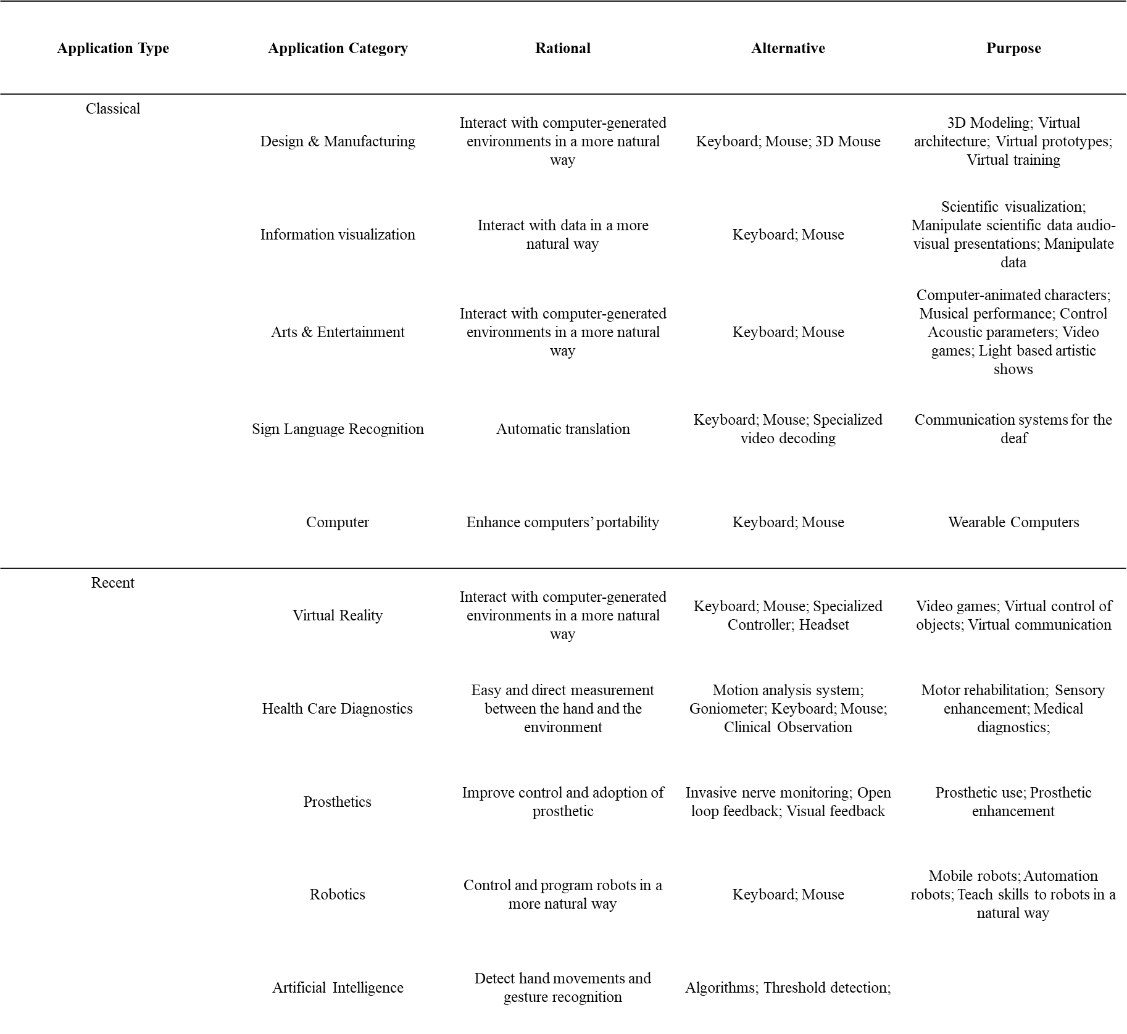

**Table 2. Academic papers of existing sensor technologies.** Academic papers are separated by sensor type. Characteristics for each sensor node are detailed below to provide a short description of the sensor.

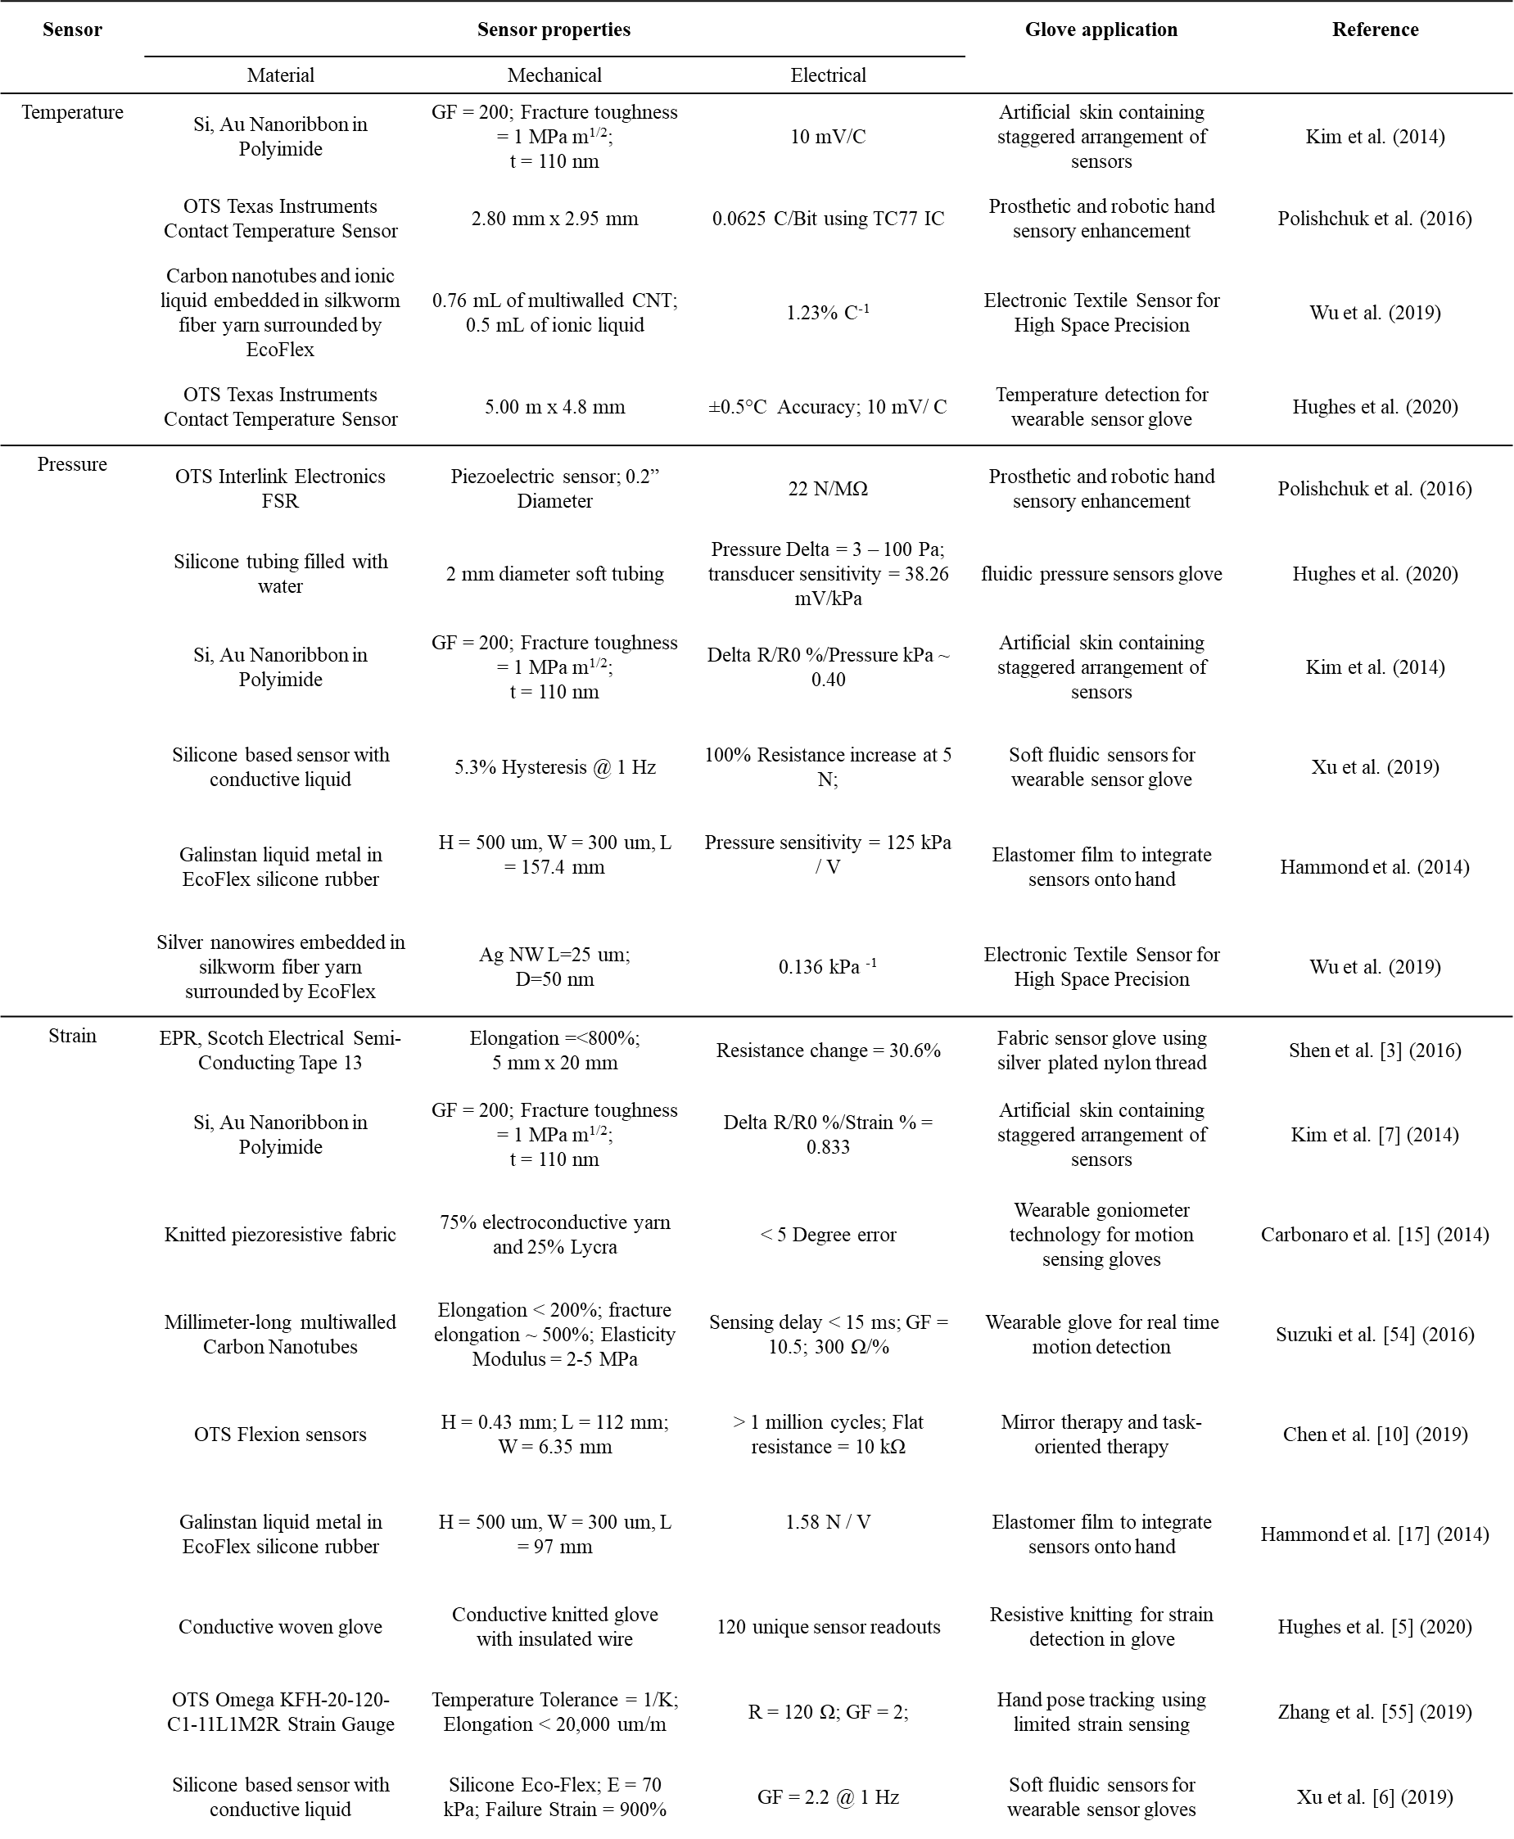

**Table 3. Summary of vibrotactile feedback in literature.**

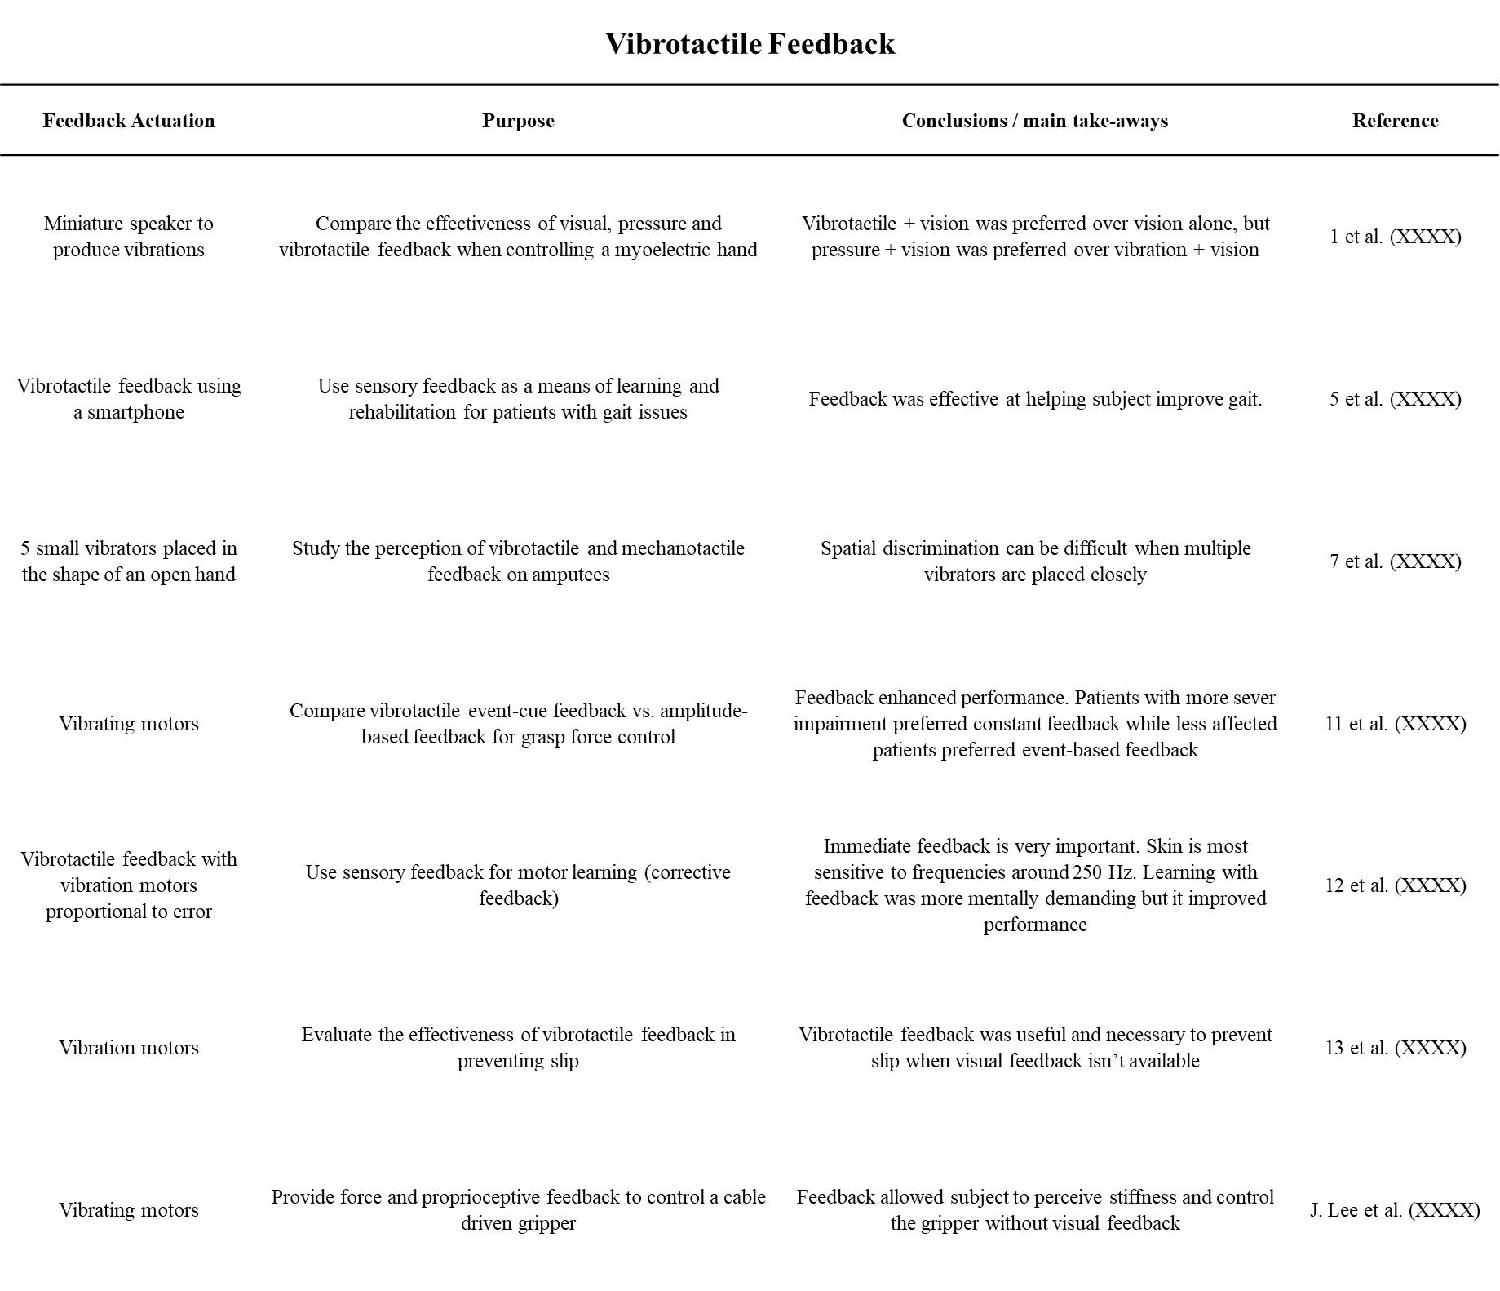

**Table 4. Summary of normal mechanotactile feedback in literature.**

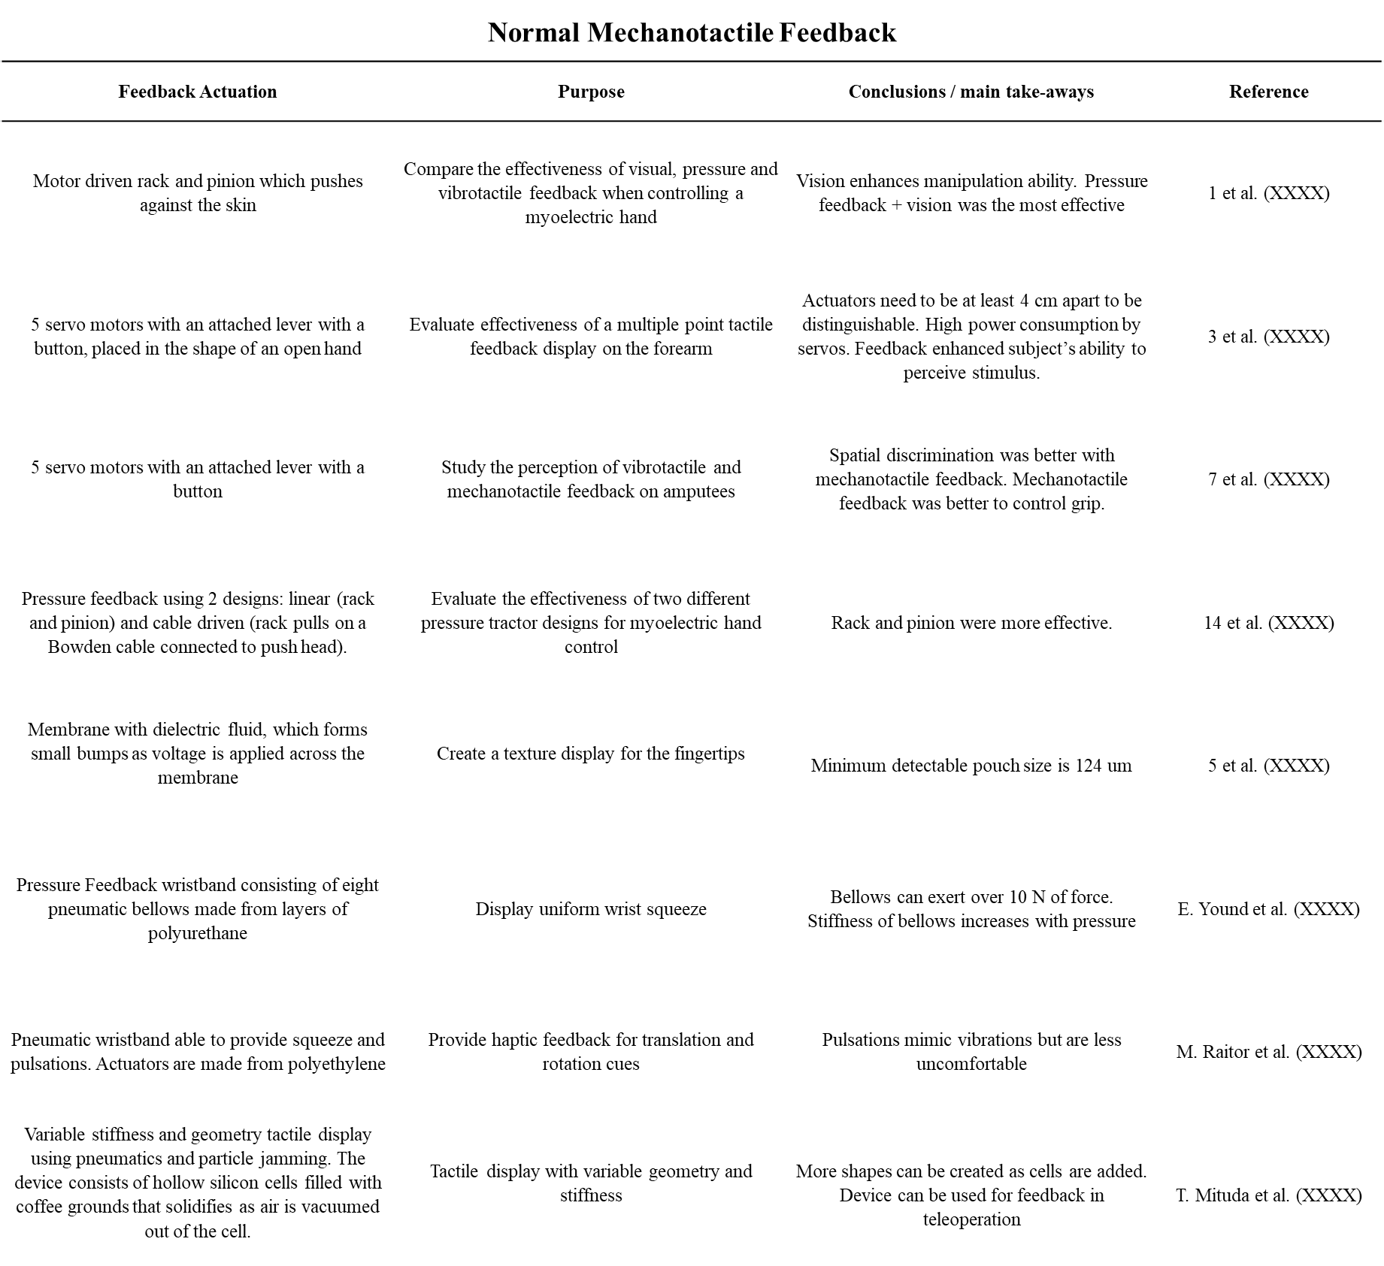

**Table 5. Summary of shear mechanotactile feedback in literature.**

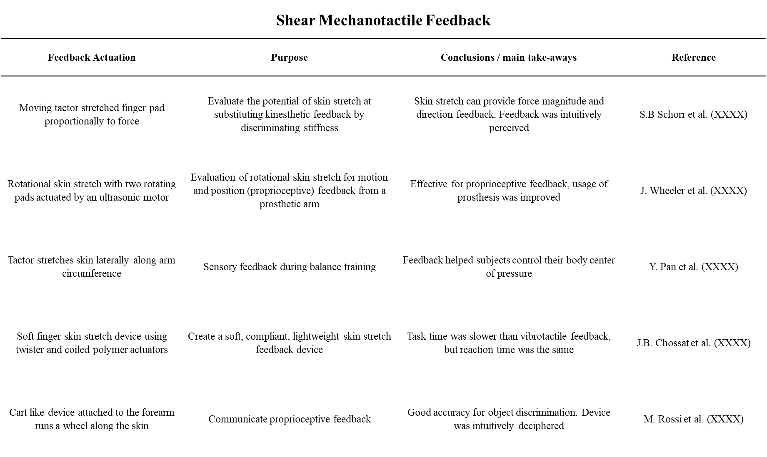

**Table 6. Pros and cons of each feedback modality.**

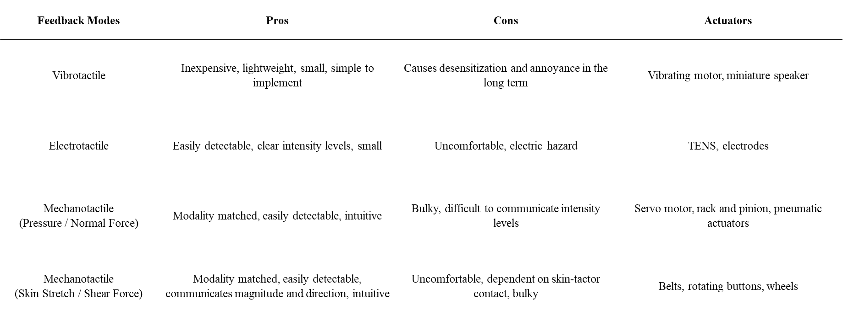

PLACEHOLDER

**Fig. 1. Combination of wearable sensing glove and transfer feedback device technology.** The fusion of these two technologies can advance the mobility of individuals with sensory impairment, peripheral neuropathy, prosthetics, diabetes, and sclerosis.

**Fig. 2. Commercial examples of wearable sensor gloves using different sensor technology.** (A) Courtesy of Novel GmbH (Novel 2021) (B) Courtesy of Virtual Realities, LLC (Virtual Realities 2018) (C) Courtesy of Sensor Holdings Limited (StretchSense 2021) (D) Courtesy of Flexpoint Sensor Systems, Inc. (Flexpoint 2021) (E) Courtesy of CaptoGlove Inc. (CaptoGlove 2020) (F) Courtesy of Bebop Sensors (BeBop 2021) (G) Courtesy of Medical Tactile Inc. (PPS 2021b) (H) Courtesy of MI.MU Gloves Limited (MimuGloves 2021) (I) Courtesy of Iron Will Innovations Canada Inc. (Peregrine 2021) (J) Courtesy of Manus Machinae BV (Manus-VR 2021) (K) Courtesy of 5DT Technologies (5DT 2021) (L) Courtesy of Vista Medical, Ltd. (Vista Medical)

**Fig. 3. Do-It-Yourself prototypes of wearable sensor gloves using different sensor technology.** (A) Courtesy from Thingiverse.com (Freedman 2016) (B) Courtesy of Instructables.com (vu2aeo 2021) (C) Courtesy of Instructables.com (Shja7942 2021) (D) Courtesy of Instructables.com (Emcnany 2021) (E) Courtesy of Instructables.com (Freire 2021b) (F) Courtesy of Instructables.com (Plusea 2021) (G) Courtesy of Instructables.com (Donaldson 2021) (H) Courtesy of Instructables.com (Freire 2021a) (I) Courtesy of Instructables.com (DanielE58 2021)

**Fig. 4. Wearable sensor gloves using different sensor technology.** (A) Glove with strain sensor made from ethylene propylene rubber (Shen et al. 2016) (B) Glove with strain sensors made from a silver nanowire layer (Chen et al. 2016) (C) Glove with strain sensors made from carbon particles embedded in nitrile butadiene rubber (Qu et al. 2020) (D) Glove with pressure sensors made from potassium iodide and glycerol solution (Xu et al. 2019) (E) Glove with pressure sensors made from Interlink 402 force sensitive resistors (Francés et al. 2019) (F) Glove with pressure sensors made from gallinstan conductive liquid (Hammond et al. 2014) (G) Glove with temperature sensors made from CNTs and [EMIM]Tf2N wrapped in conductive yarn encapsulated in Ecoflex (Wu et al. 2019) (H) Glove with temperature sensors made from off the shelf Ti TC77 ICs (Polishchuk et al. 2016) (I) Glove with temperature sensors made from MWNTs and PDMS (Li et al. 2020b) (J) Artificial skin with pressure, strain, and temperature sensors made from single crystalline silicon nanoribbon (Kim et al. 2014).

**Fig. 5. More examples of wearable sensor gloves using different sensor technology.** (A) Temperature sensors made from liquid Galinstan material. (Ota et al. 2016) (B) Temperature sensor made using Ti LM35 ICs (Hughes et al. 2020) (C) Temperature sensors made from strain‐insensitive fiber with compressed micro‐wrinkles (Lee et al. 2020) (D) Strain sensor made from poly nanofibrils percolated in silicone elastomer (Kim et al. 2018) (E) Strain sensor made from vinylidene fluoride nanofibers (Khan et al. 2018) (F) Strain sensor made from millimeter-long multiwalled CNTs (Suzuki et al. 2016) (G) Pressure sensor made from embedded Galinstan microchannels (Gao et al. 2017) (H) Pressure sensor made from anti-static sheets and conductive woven fabrics (Pizarro et al. 2018) (I) Pressure sensor made with an air dielectrics for transparent and wearable pressure sensor array (Ji et al. 2020)

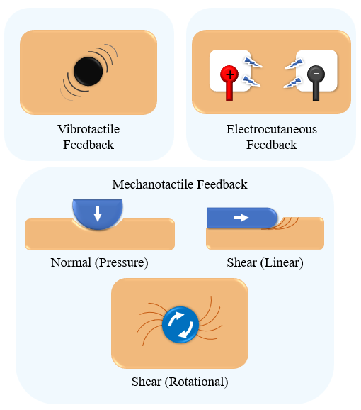

**Fig. 6. Illustration of the different feedback modalities.**

**Fig. 7. Normal mechanotactile feedback actuators.** (A) Normal force applied through servos (Antfolk et al.). (B) Normal force applied with a tactor actuated by a rack and pinion- left, and a Bowden cable- right (Schoepp et al.). (C) Dielectric fluid actuated pouches for normal feedback (Kyungwon et al.) (D) Balloon array for fingertip force feedback (King et al.). (E) Normal force applied by pneumatic bellows creating squeeze (Young et al.). (F) Geometry tactile display (Mitsuda et al.). (G) Pneumatic wristband capable of pulsating (Raitor et al.)

**Fig. 8. Mechanotactile feedback actuators.** (A) Rotational skin stretch double head tactor (Bark et al.). (B) Wheel lateral skin stretch wearable device (Rossi et al.). (C) Finger pad skin stretch using a moving tactor (Schorr et al.). (D) Lateral skin stretch wearable device for balance training (Pan et al.). (E) Soft skin stretch TCP actuated device (Chossat et al.).